|  |
| --- |
| Embedded Systems Lab Experiment 6 |
| Display Text on 16x2 LCD using ATMega 32 Microcontroller |
| Program an ATMega 32 to display text on 16x2 LCD in 4 bit mode |

|  |
| --- |
| Jitbitan Baroi  3-2-2024 |

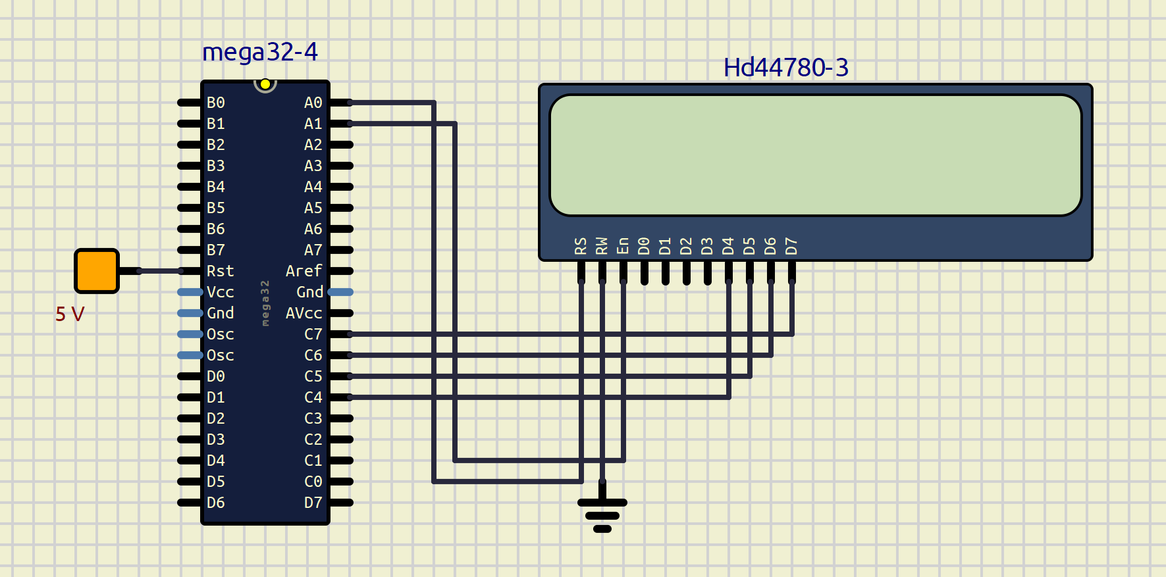

Schematic used for displaying text